**Work break down structure and activity:**

Module wise:-

1. **Admin Module:**
2. Crud operation of users
3. Crud operation of Events
4. Crud operation of Tittles
5. Accounting details and check payment
6. Attendee Taxable Amounts
7. Reporting

**Activity: -**

1. **Authentication and Authorization**
2. Role access management
3. User access management
4. Encryption
5. Dynamic menu binding
6. **Database cloning**
7. Generate database structure
8. Aws+ Rds database implementation
9. **Analyze existing code**
10. **Framework and Architecture**
11. Middleware
12. Repository pattern
13. Layered based

**Question:-**

1. Reporting Module belong to current database or any dependency is there to get data from other database? Need clarification

**Screen /tab**

1. **Registration:-**
2. Under registration what does the sub tab do **Dealer Pull kept** and **Dealer Pull Order**

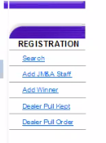

1. On list when we edit that user list again in registration sub tab had new sub tabs [**Add dealer Association, Add guest** ]

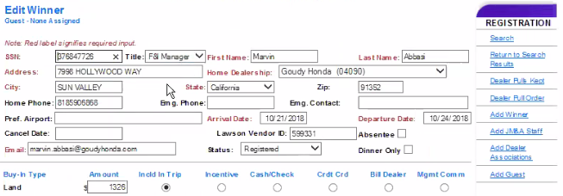

1. **Check-in:-**
2. What exactly **check balance** sub tab do functional flow and business logic needed

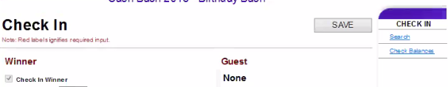

1. Check payment:
2. Check request file to the accounting service (ETL) ETL process
3. Transformation and transmission of file check (NetSuite Financial System)